Week 1

HTML Example 1

css text images ans dives

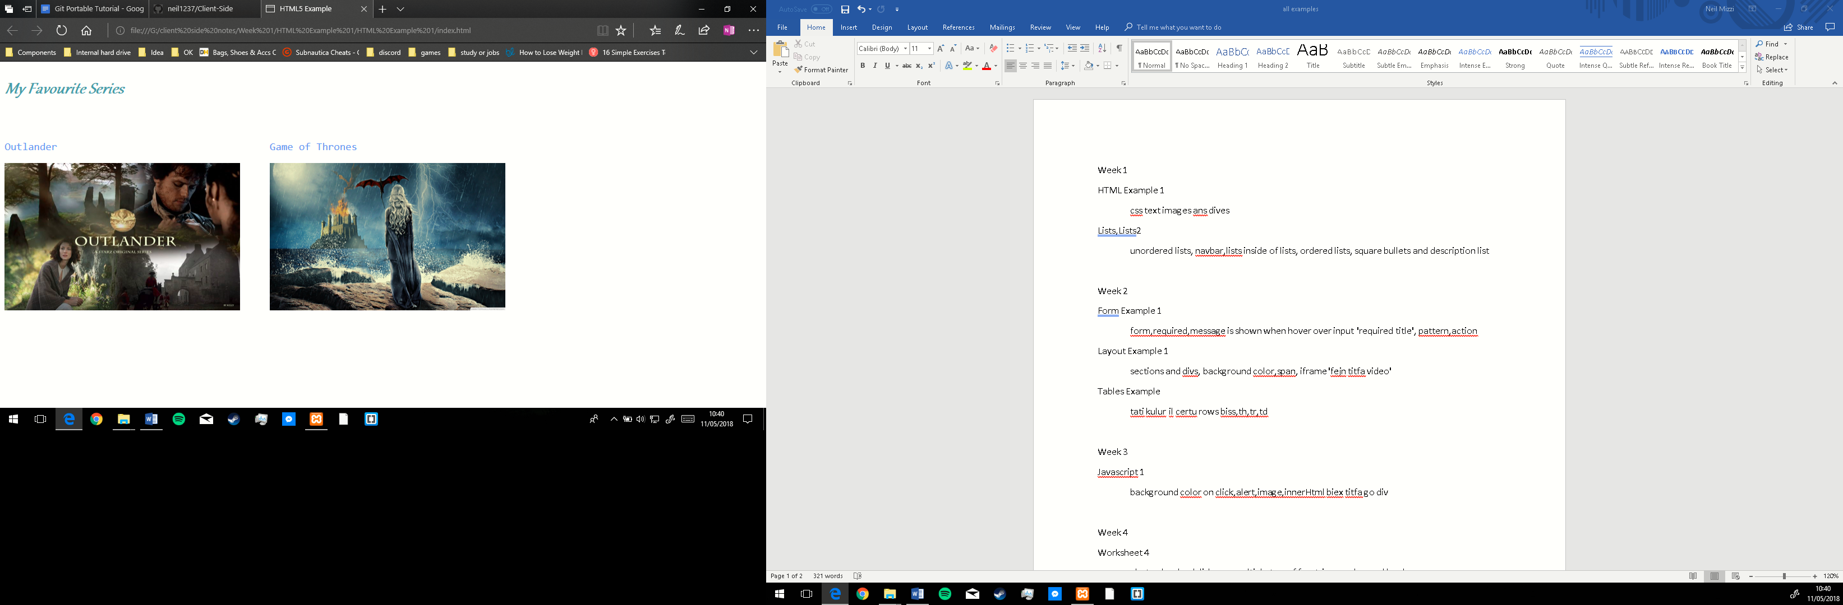

Lists,Lists2

unordered lists, navbar,lists inside of lists, ordered lists, square bullets and description list

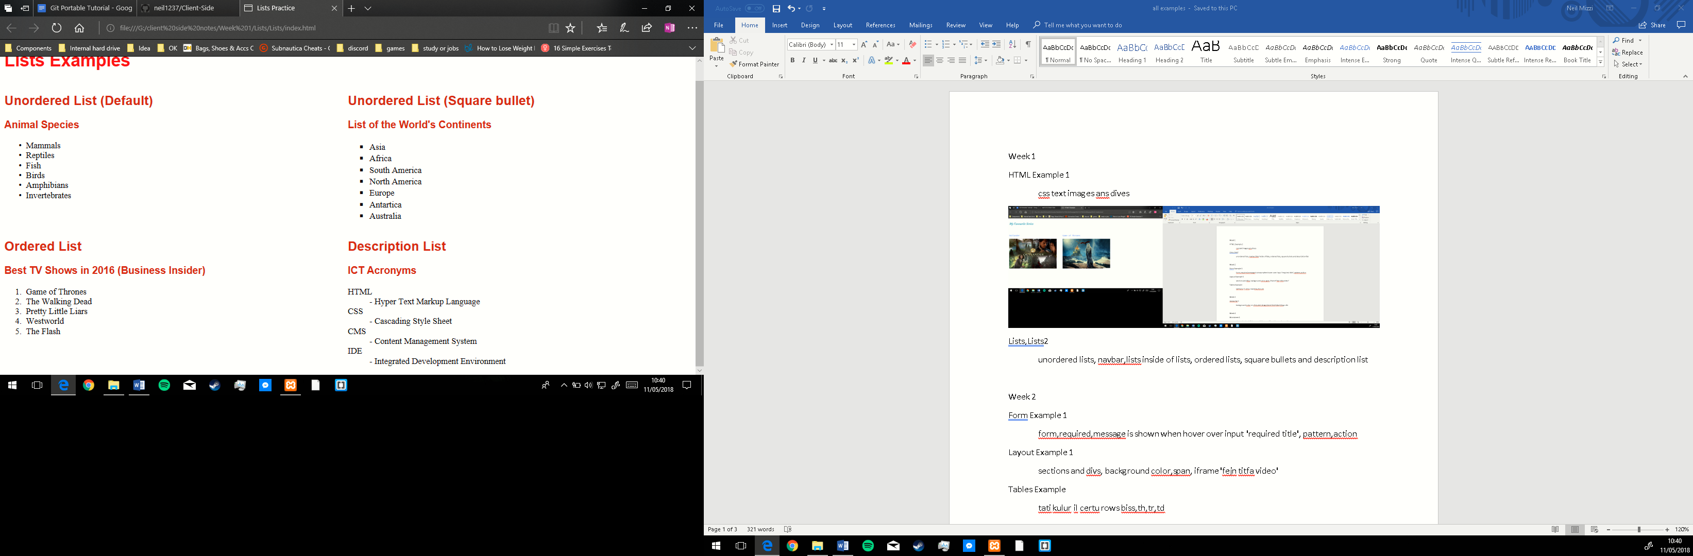

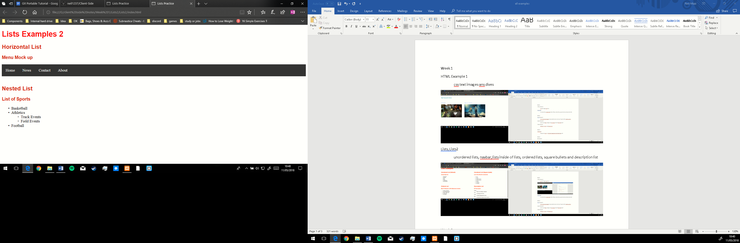

Week 2

Form Example 1

form, required, message is shown when hover over input 'required title', pattern, action

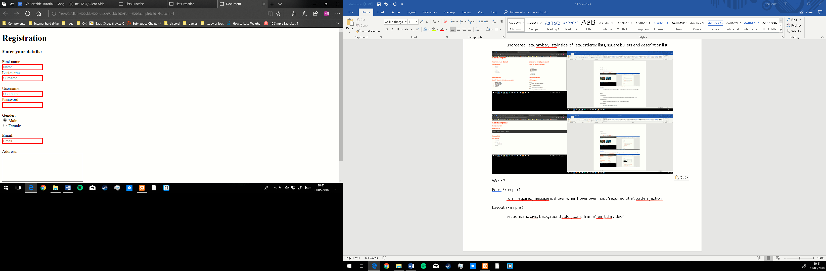

Layout Example 1

sections and divs, background color,span, iframe 'fejn titfa video'

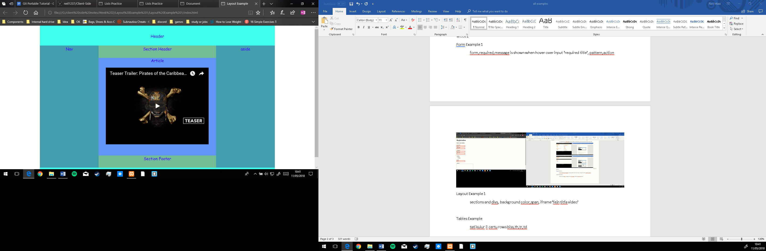

Tables Example

tati kulur il certu rows biss,th,tr,td

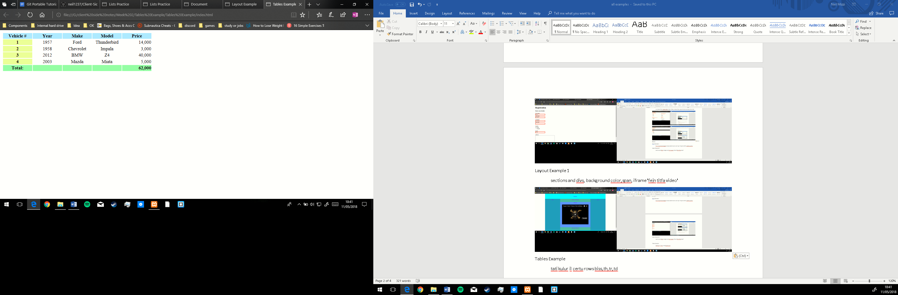

Week 3

Javascript 1

background color on click,alert,image,innerHtml biex titfa go div

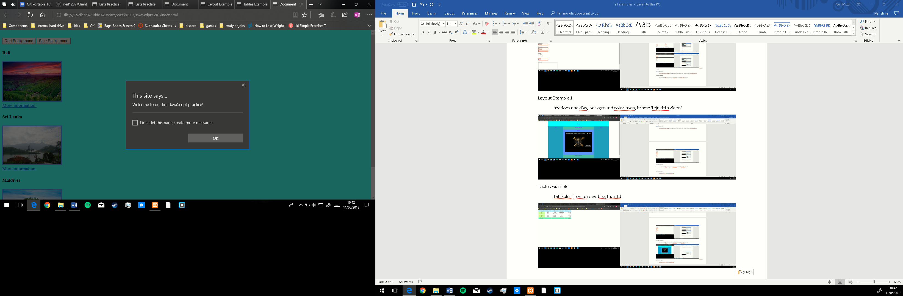

Week 4

Worksheet 4

alert onload,onlclick,sum,multiply,typeof for string number and Boolean

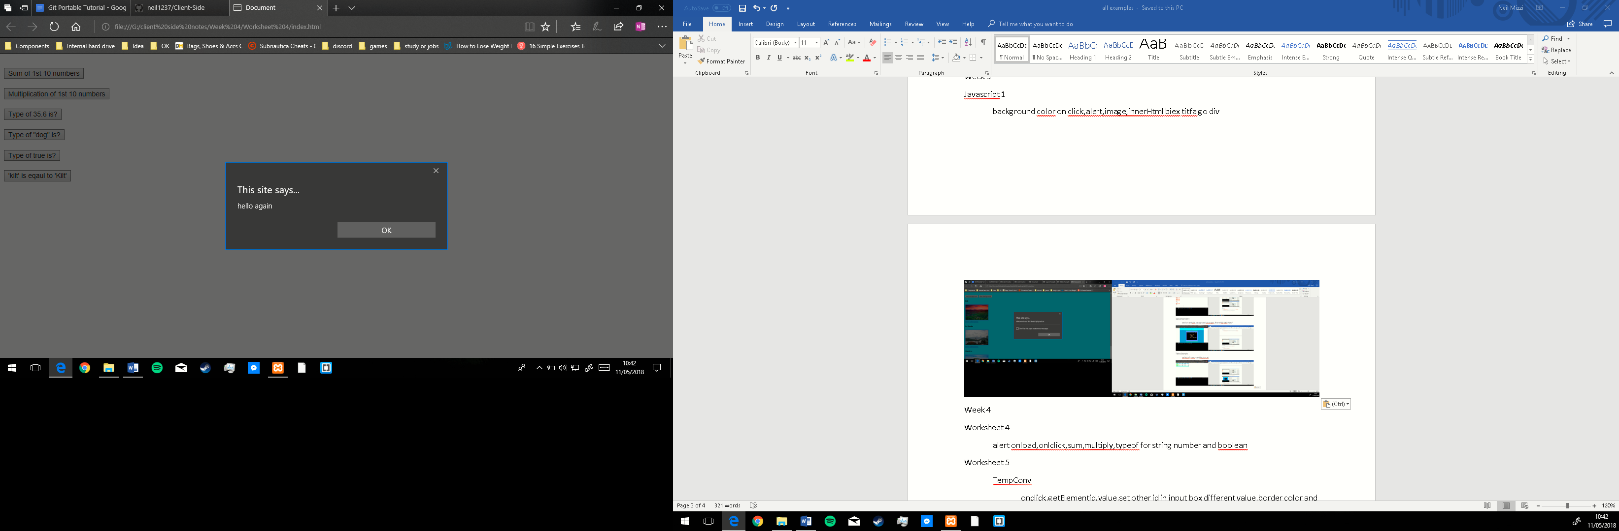

Worksheet 5

TempConv

onclick,getElementid.value,set other id in input box different value,border color and style arround div

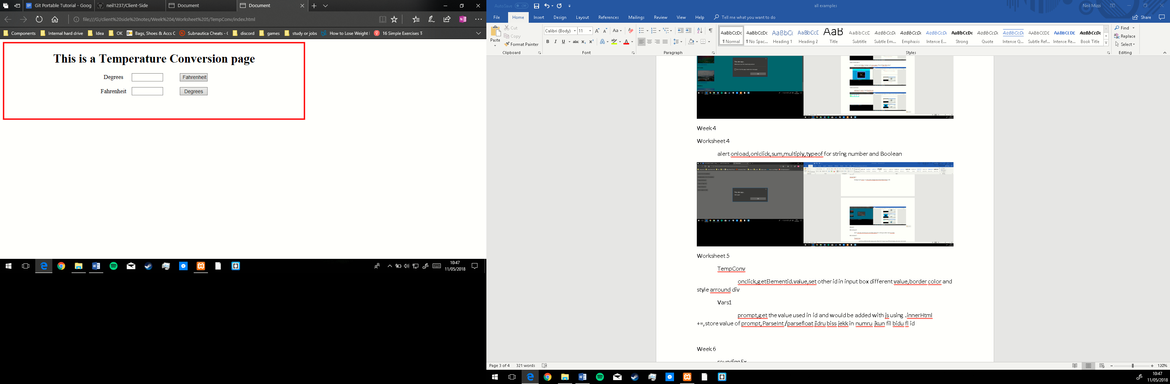

Vars1

prompt,get the value used in id and would be added with js using .innerHtml +=,store value of prompt,ParseInt /parsefloat jidru biss jekk in numru jkun fil bidu fl id

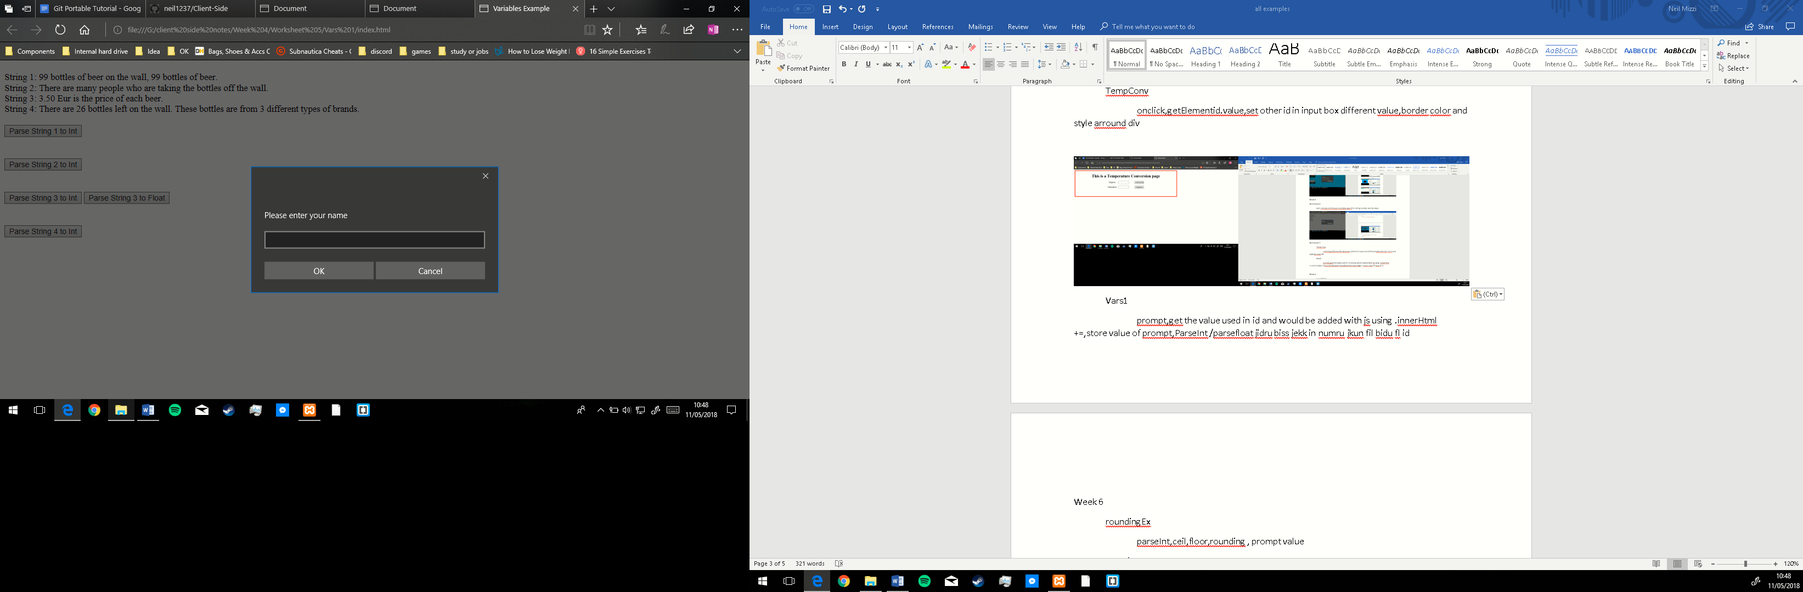

Week 6

roundingEx

parseInt,ceil,floor,rounding , prompt value

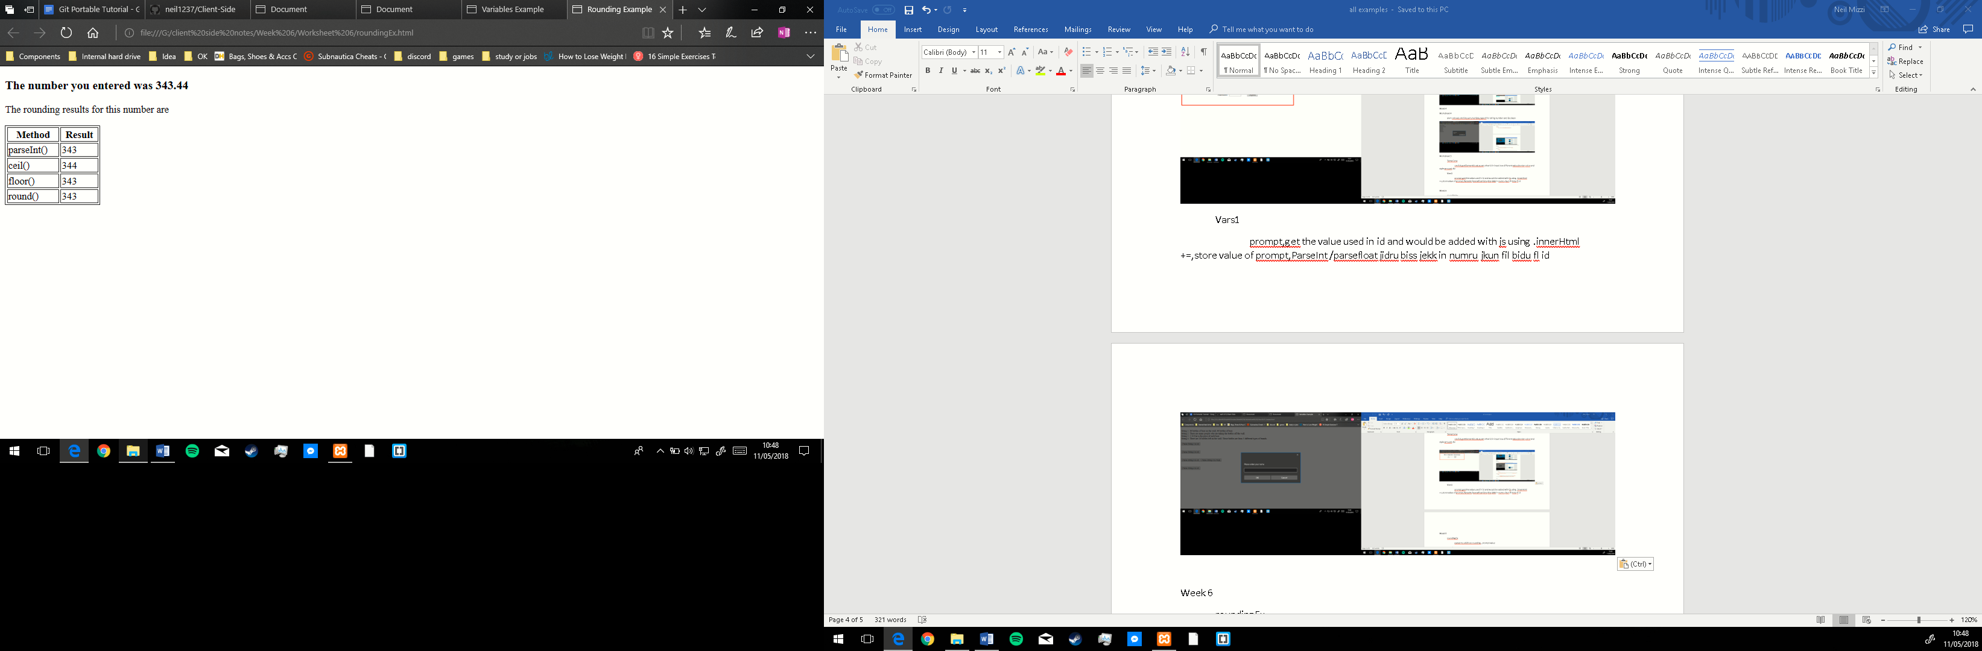

Functions 1

functionexamples

dateFormat(day month year millisecond time), substring , indexOf,

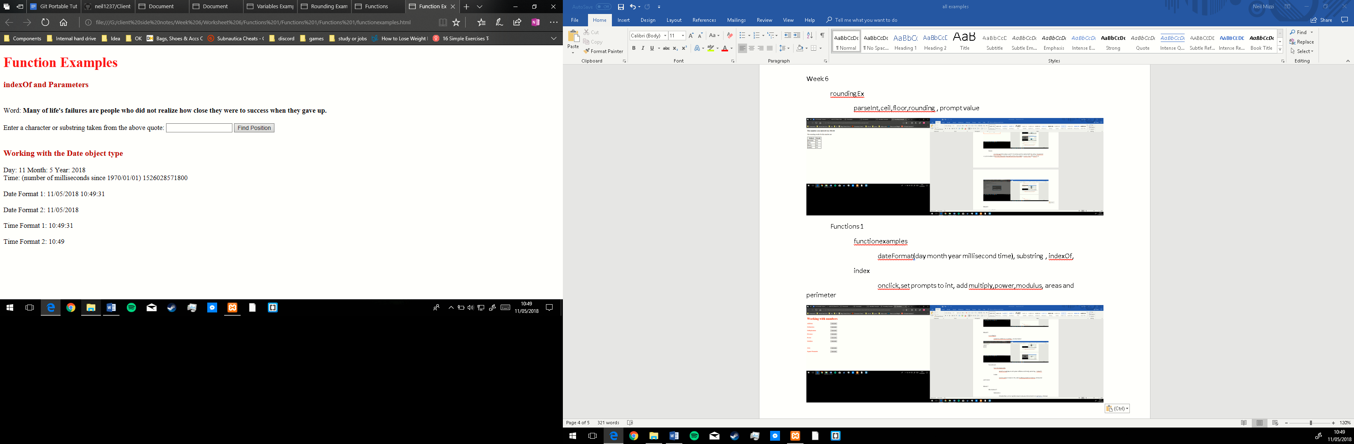

index

onclick, set prompts to int, add multiply, power, modulus, areas and perimeter

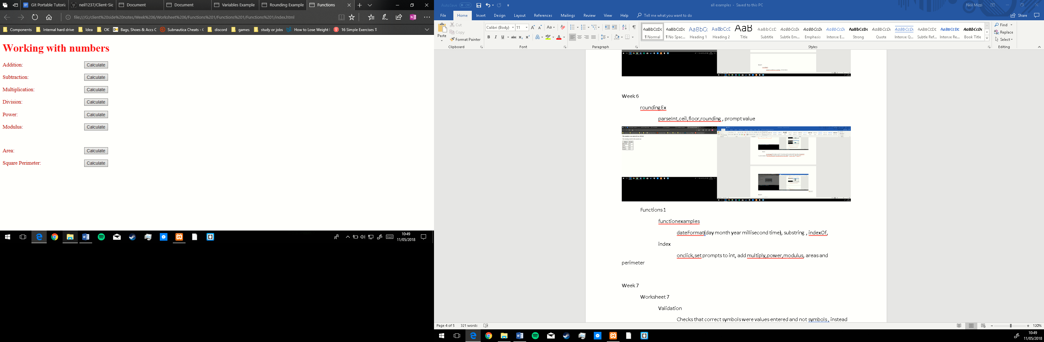

Week 7

Worksheet 7

Validation

Checks that correct symbols were values entered and not symbols, instead of using if statement for if correct name is entered another value would be shown instead of it

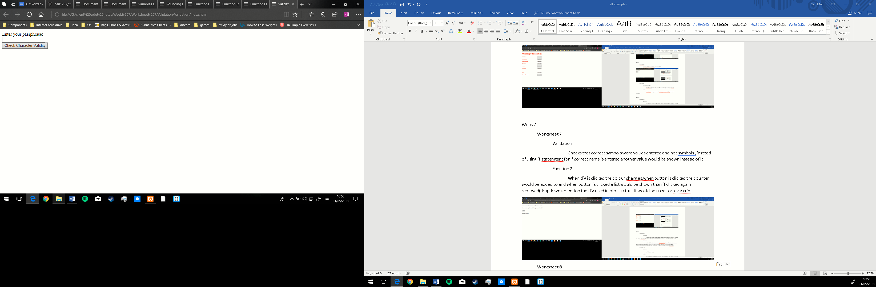

Function 2

When div is clicked the colour changes, when button is clicked the counter would be added to and when button is clicked a list would be shown than if clicked again removed(dropdown), mention the div used in html so that it would be used for JavaScript

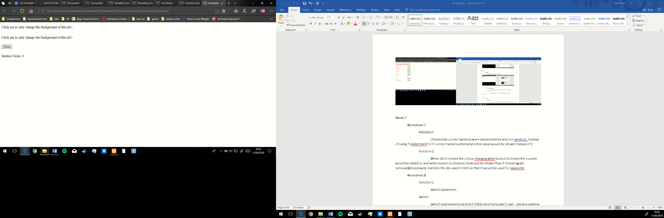

Worksheet 8

Function 1

switch statement,tamel min numru al month

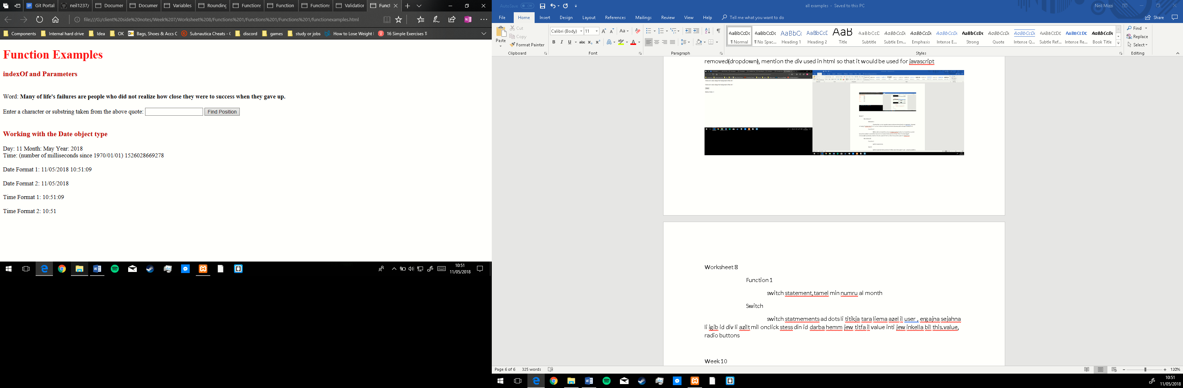

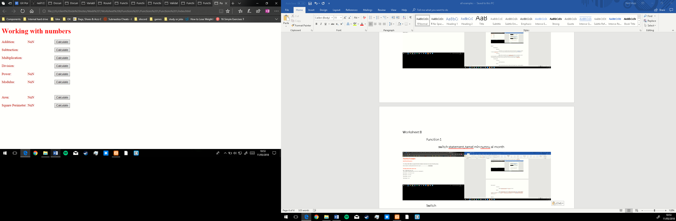

Switch

switch statements ad dots li titikja tara liema azel il user , ergajna sejahna li igib id div li azilt mil onclick stess din id darba hemm jew titfa il value inti jew inkella bil this.value, radio buttons

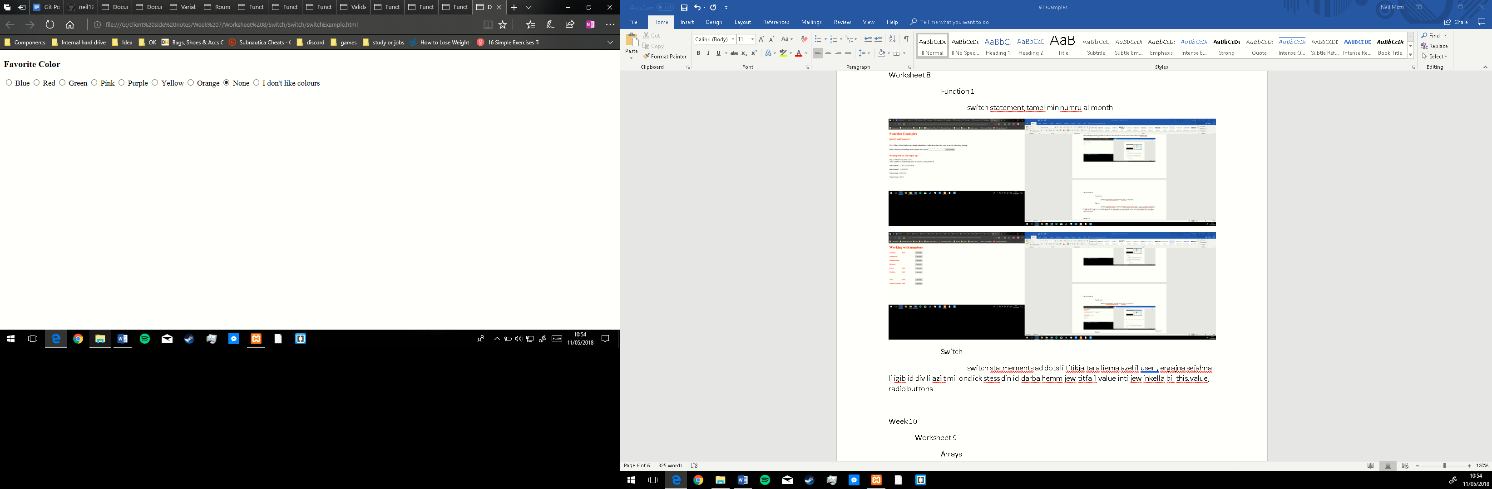

Week 10

Worksheet 9

Arrays

Andek array create u meta titfa numbru issib l value li ridt mil array, tista izzid inti mal array, tista tazel jekk jibdiex mil 1 jew 0, tista tamel sort il array ukoll.

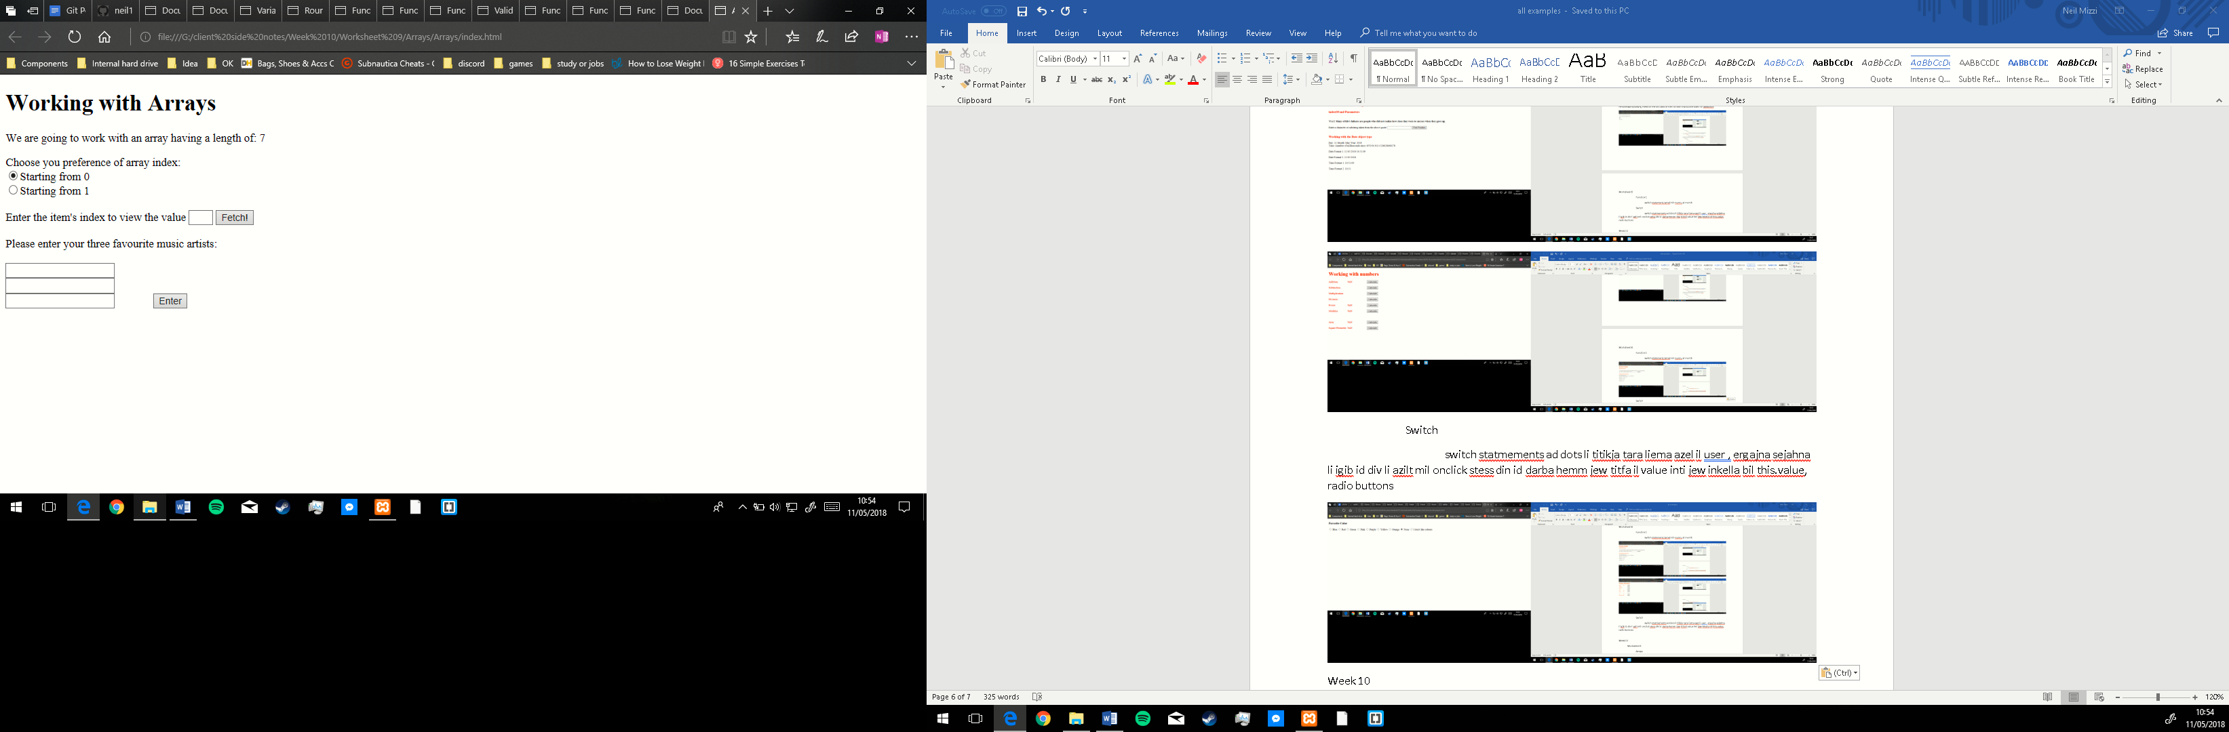

Week 12

Objects

Index Script.js

get element by id tal button, creation of array,array with different values, create one object,create function in object ,place image with javascript

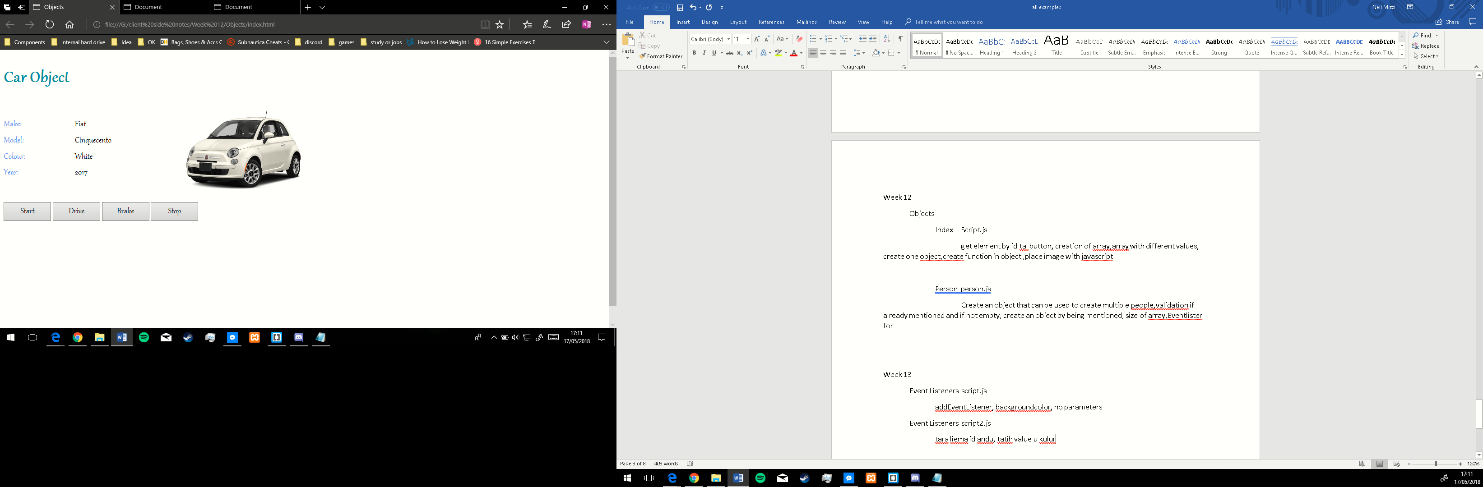

Person person.js

Create an object that can be used to create multiple people, validation if already mentioned and if not empty, create an object by being mentioned, size of array, Event listener for button clicks

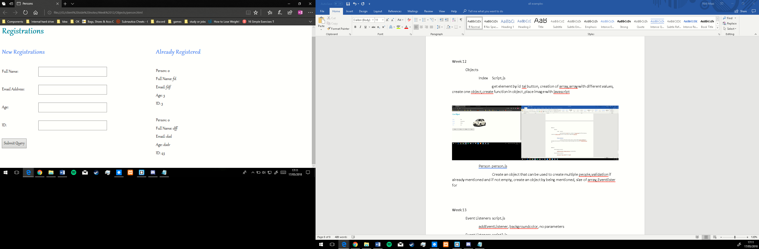

Week 13

Event Listeners script.js

addEventListener, backgroundcolor, no parameters

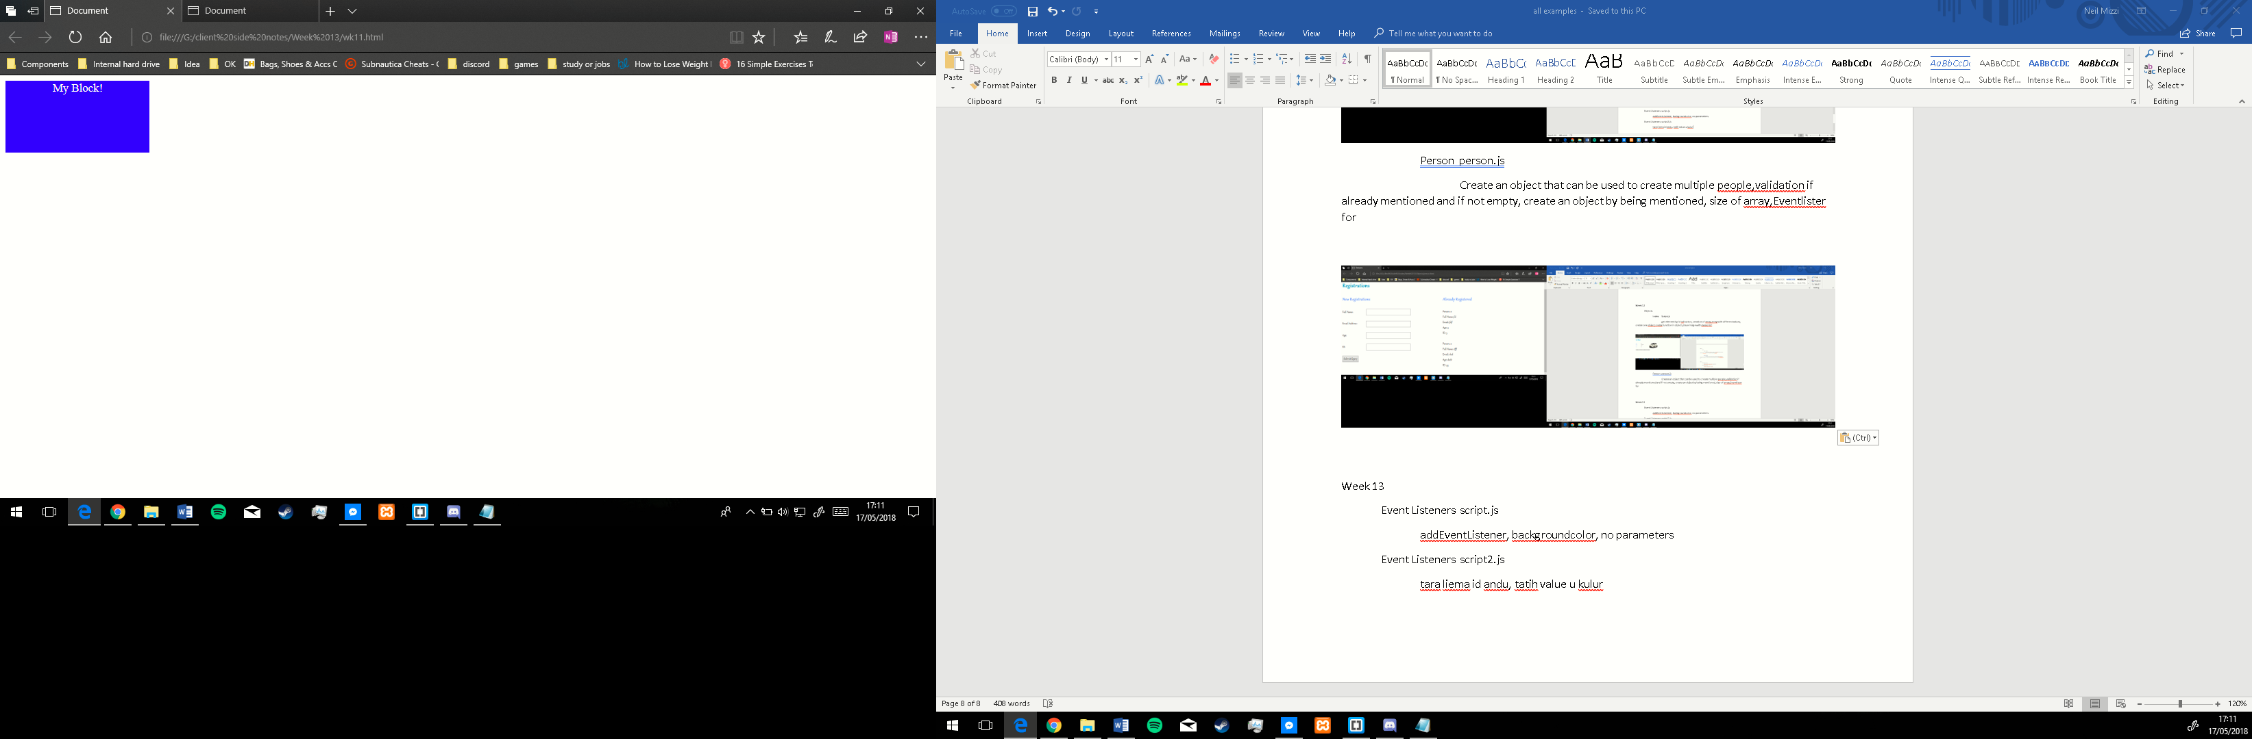

Event Listeners script2.js

tara liema id andu, tatih value u kulur

